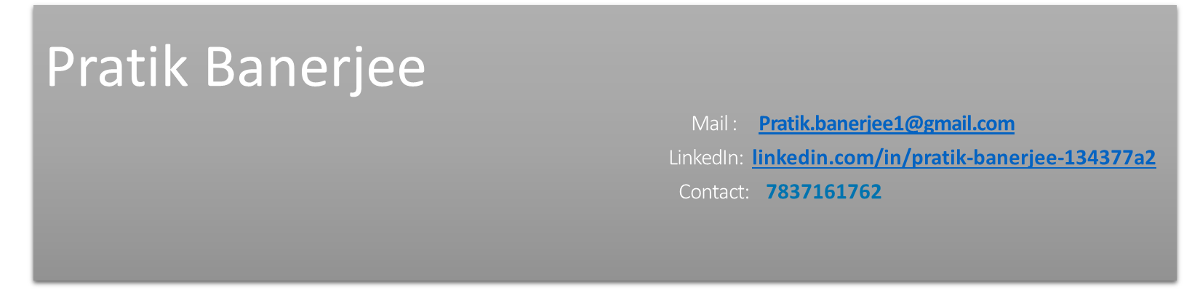
About Me
Looking for opportunity to excel in the field of Information Technology. I am committed to contributing continuously towards organizational growth by providing seamless learning and delivery. Every opportunity is utilized to achieve both my personal and professional development, as I embrace challenges and remain dedicated to advancing in this dynamic domain.
Having professional experience to work on different instrumentation sector both at office and client place as service engineer.
Immediate joiner and ready to work on 24*7 model of project.

IT Skills and Expertise
- Certified in “Administering Microsoft SQL Server 2012/2014 Databases” from IBM
- Self-learned database restoration, Database creation and done hands-on on the same
- IBM certified Data analysis with Python
- Persuading Web design & development Certification Training from Ardent Collaboration
- Worked on Microsoft Word, Excel, and PowerPoint

Professional Experience
Overall, 5 years’ experience in different Instrumentation project for different organization. Worked on relevant industry related software on maintenance role service engineer.
Currently upskilling in IT skill and available for immediate join.

Organization | Designation | Duration | Job role
Thermax Limited | Project Management Consultant | Jan 2022 to July 2022 | Worked on the ERP & MIS reporting of the client. (SQL server 2022)  Integration of SQL server with the Web SCADA
Emerson | System Engineer | November 2019 to December 2021 | Worked on software upgrades & maintenance Patches updates.  Security app installation
Yokogawa | Field service consultant | April 2017 - October 2019 | PID graphics design at client location

Educational Background

B. Tech, Electronics and Instrumentation (2011 – 2015)

Techno India College of technology.

Personal Details

Date of Birth | 31/10/1992
Marital Status | Single
Address of Residence | 2C/201 Shakuntala Residency, Chandannagore, West Bengal – 712136, India
WhatsApp Number | 9902836405

