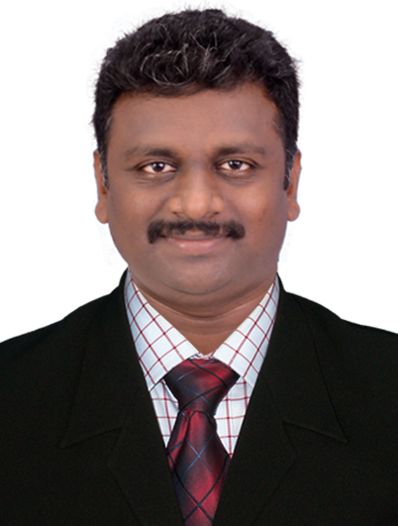  SENTHIL ARAVIND. K  SENIOR PIPING ENGINEER  (Oil & Gas Refinery, Petrochemical Piping & Pipeline projects)  Overall Experience: 16 years  GCC Experience: 08 years  (Countries worked: Saudi Arabia, Qatar, Oman, UAE & Libya)  Email:  k.senthilaravind@gmail.com  Contact number:  +917604967387  Address:  20-110, Srilekshmipuram  Variyoor post, Kanyakumari Dist.  Tamil Nadu – India.  Pin code: 629401.  Personal Details: | OBJECTIVE:  To pursue a challenging carrier in Mechanical Construction field by which I can enhance my technical and personal skills and develop along with the concern.  KEY SKILLS:  Familiar with ASME B31.3, B31.4, B31.8, ASTM, ANSI, NACE, API, IBR Codes and Standards  TECHNICAL SKILLS:  Piping & Pipeline project execution, Fabrication & Erection, site engineering & project management, Project Planning & Scheduling preparation, Front-end engineering design (FEED), Detail Engineering, Material take off, Quality inspection, piping materials specification (PMS), Valve materials specification (VMS), Test package preparation, Hydro & Pneumatic test, Pipeline Pigging, Pre-commissioning, Field Engineering, Turn around.  COMPUTER SKILLS:  PDMS, Navis smart plant 3D & SPR piping model, Auto spool software, MS Office, AutoCAD 2000, SAP, Project planning and Schedule Chart.  PROFILE SUMMARY:  A visionary and competent professional with over 16 years of rich cross-functional experience in Site Engineering and Project Management of EPCM & PMC companies. I have gained diversified professional experience in various work areas, such as  - Senior Construction Engineer (Piping & Pipeline)  - Lead Piping Construction Engineer  Piping Fabrication and Erection experience in Oil & Gas Refinery, Petro Chemical, Green field & Brown field, Lump-sum turnkey LSTK), Onshore well head X-mas tree connection, Nuclear power plant Industries working and Technical Knowledge in piping Construction, Static, Rotary Equipment maintenance and gas related pipelines.  EDUCATIONAL QUALIFICATION:  DIPLOMA IN MECHANICAL ENGINEERING – 2004  Moderator Gnanadason Polytechnic College, Nagercoil, Kanyakumari Dist., Tamil Nadu-India  DESIGN TRAINING:  PDMS (Plant design & management system) Version 12.0  (Aveva Solution Ltd)

Nationality | : | Indian
Marital status | : | Married
Date of Birth | : | 11-06-1984
Father Name | : | Kannadhason
Languages known | : | Fluent in English, Tamil Hindi, Malayalam
Passport Details:

Passport No | : | N5555463
Issued Place | : | Madurai
Date of issue | : | 18-12-2015
Date of expiry | : | 17-12-2025
CURRICULUM VITAE

WORK EXPERIENCE

I. | 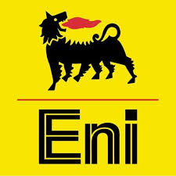 | Senior Construction Engineer - (Piping & Pipeline) Jan 2019 - Jan 2020  ENI Group B.V Limited (Mellitah Oil & Gas B.V) – Libya (Tripoli)
Project : Western Libya Gas Project (WLGP)

Plant : Gas inlet compression unit & Well head RIG to Satellite gathering unit (Flow Line).
Owner : Mellitah Oil & Gas B.V (Libyan Branch)
Client : AGIP - ENI North Africa B.V (Libyan Branch)
Plant Capacity : 323,000 Bbls of Oil Equivalents (BOE) per day

II. | 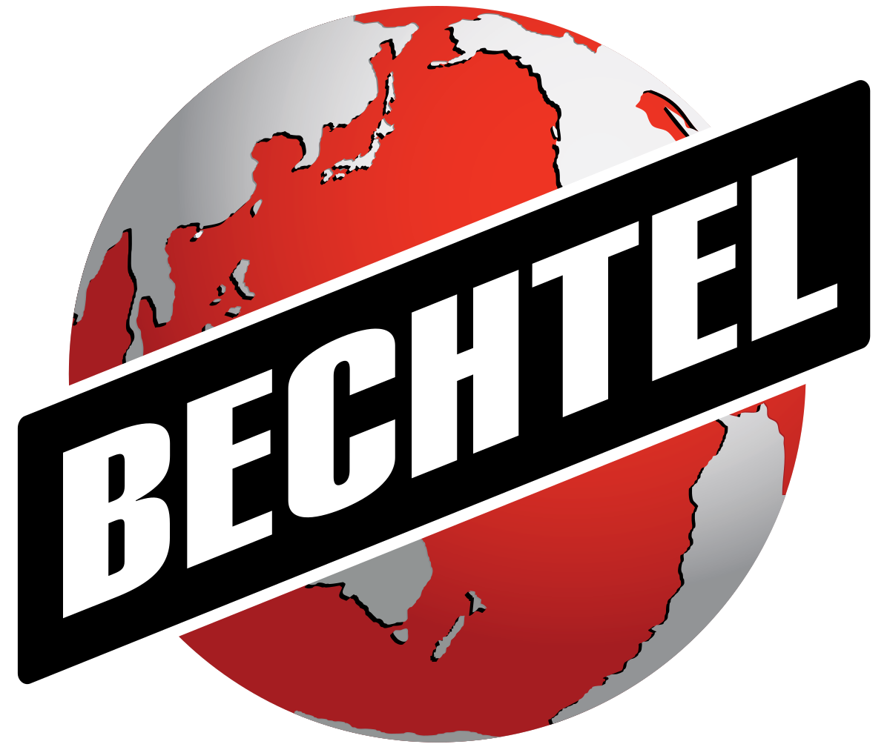 | Piping Field Engineer Apr 2018 - Nov 2018  Bechtel Corporation International Limited – UAE (Abu dhabi)
Project : Al Taweelah alumina refinery project (ATA)
Plant : Bauxite mine to aluminium production
Owner : Emirates global aluminium (EGA)
Client : Bechtel & Petrofac joint venture (BPJV)
Plant Capacity : 2 million tonnes per annum

III. |  | Lead Piping Construction Engineer (Shutdown Project) Aug 2017 - Dec 2017  W.J. Towell Group (Engineering & Construction) – Oman (Sohar)
Project : Liwa plastics Industrial complex (LPIC)
Plant : Polypropylene (PP) & Utilities EPC package-II
Owner : ORPIC (Oman oil refineries & petroleum industrial company)
Client : Maire Tecnimont s.p.a Italy
Plant Capacity : 300,000 tonnes per year

IV. | 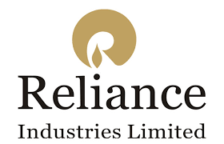 | Senior Piping Construction Engineer Feb 2016 - Jul 2017  Reliance Industries Limited – India (Jamnagar)
Project : Reliance Gasification Project -J3
Plant : Acid Gas Removal (AGR) & Low Temperature Heat Recovery (LTHR)
Owner : Reliance Industries Limited-RIL
Consultant : Flour Corporation India Limited / Linde AG pvt Limited
Plant Capacity : 160, 000 Barrels/day Gas Products and base Oils

V. | 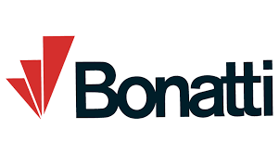 | Piping Construction Engineer Nov 2014 – Oct 2015  Bonatti Arabia S.p.a Limited – Saudi Arabia (Jubail)
Project : Saudi Basic Industries Corporation (SABIC)
Plant : Carbon Dioxide Purification and Liquefaction
Owner : Jubail United Petrochemical Company (UNITED)
Client : Linde Ag Gmbh (Engineering Division)
Plant Capacity : 1,500 Tons per day

VI. | 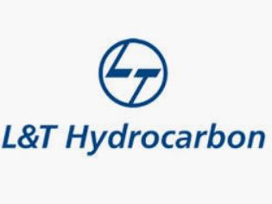 | Senior Mechanical Engineer (Piping) Jan 2014 – Oct 2014  Larsen & Toubro Hydrocarbon Engineering & Construction – India (Dahej)
Project : Reliance DMD Project (Dahej Manufacturing Division)
Plant : Production Process for Purified Terephthalic Acid (PTA)
Owner : Reliance Industries Limited-RIL
Consultant : Aker Power Gas India Limited
Plant Capacity : 2.30 Million Tons per Annum

VII. | 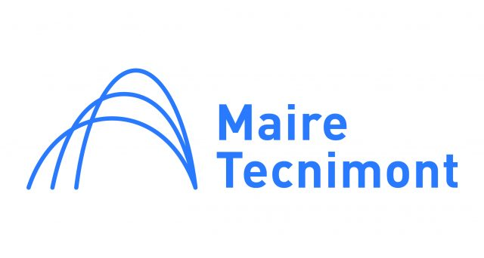 | Piping Engineer Aug 2010 – Dec 2013  Maire Tecnimont S.p.a Limited – India (Mangalore)
Project : MRPL Project Phase -III
Plant : Heavy Cooker Gas Oil Hydro Treating Unit-CHTU
Owner : Mangalore Refinery & Petrochemical Limited (MRPL)
Client : Engineer’s India Limited (EIL)
Plant Capacity : 6.50 Million Tons per Annum

VIII. | 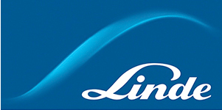 | QC Piping Inspector Nov 2008 – Jun 2010  Linde Gama Qatar Co. W.L.L – Qatar (Raslaffan)
Project : Qatar Pearl Ras Laffan Project
Plant : Gas to Liquid, Air Separation Unit (GTL-ASU)
Owner : Qatar Shell Petroleum Co.
Consultant : JGC Middle East Fze / KBR-Kellogg Brown & Root International Inc. (JK)
Plant Capacity : 140, 000 Barrels/Day GTL Products and Base Oils

IX. | 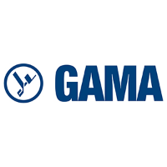 | Piping Supervisor Oct 2006 – Jul 2008  GAMA Industry Arabia Ltd – Saudi Arabia (Hafuf)
Project : Gas Treatment Compression Facilities Project
Plant : Hawiyah-2 Natural Gas Line Recovery Plant
Owner : Saudi Aramco (Saudi Arabian Oil Company)
Client : Snamprogetti Arabia Limited (Saipem Eni Group)
Plant Capacity : 3,800 Million Cu.Ft. /D of Gas, 310,000 Bpd of NGL Products.

X. | 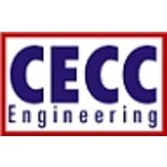 | Piping Engineer (Junior) Apr 2004 – Aug 2006  Cawnpore Engineering & Construction Company – India (Kudankulam)
Project : Nuclear Reactor Power Plant Project
Plant : Kudankulam Nuclear Power Plant – Reactor 1 & 2
Client : Nuclear Corporation of India Limited (NPCIL)
Contractor : Cawnpore Engineering and Construction Company
Plant Capacity : 2x1000 Mega Watts

Job Responsibilities:

- To estimate, plan, execute and complete the construction of assigned projects according to strict deadline and budgets. Coordinating with subcontractors, consultants, vendors and suppliers in order to deliver completed projects.
- Work with the contractor’s supervision, planning engineers, and the Construction Engineer develop detailed daily and weekly work plans in accordance with the overall planning schedule.

- Responsible for construction piping activities through the contractor’s supervision in respect of HSE, method, working practices, quality and timely execution of the works.
- Review and monitor the availability of drawings, specifications, job instructions, material deliveries and tools applicable to the particular discipline and area of work.

- Coordinate with engineering on constructability and design issues relating to the piping discipline such as underground and above ground piping installation and pipe supports.

- Responsible for technical & engineering support to field supervisors required at site.

- Creating designs in PDMS and (new) drawings in electronic format (AutoCAD), studying all types of drawings (GAD, P&ID, Isometrics, Support Detail Drawings) and specification of the job in advance and listing down the scope of work.

- Document update / modify engineering design drawings according to the requirements & received mark-ups.

- Update all the as-built redline mark-up engineering documents in Native file & Smart plant database applications (PDMS)

- Preparing isometrics for piping fabrication, providing quality assurance reviews and detailed checking support and maintaining / monitoring drawing development progress.

- To conduct Site Topographical survey (for Pipeline Routing & any crossing) activity with engineering team to propose new routes where interference occurs in the alignment sheet.
- Good Knowledge in Under Ground (UG) pipeline activities like 3 Layer external coatings, Cathodic Protection, trenching, sand bedding, Electrical & Fiber optic cable (FOC) laying etc.
- Review the contract documents (drawings and specification related to the discipline), advise the Construction Manager of regarding deficiency, and raise TQ accordingly.

- Review Project scope, preparation of material requisition, material selection, data sheets and specification.

- Checking the pipe support according to predefined standards and referring stress isometric drawings for support requirements like direction of movements of the line during operational conditions.

- Technical Evaluation of vendor offers, Vendor discussions, Vendor drawing reviews, follow up vendor inspection visits etc.

- Ensuring the number and type of pigs to be used for cleaning and inspection of pipelines like Oil lines, Gas lines and water injection lines.

- Perform pig size calculations including upstream and downstream pressure, volume and other requirements for cleaning, inspection and Nitrogen services of the lines.

- Plan and supervise the piping activities on daily basis. Ensure compliance with contract requirements as per the approved Project Construction schedule.

- Awareness for weld-map with WPS-PQR for carbon steel, stainless steel, duplex steel and Nickle alloys materials.

- Inspect the equipment’s (motors, pumps, pressure tanks/vessels, piping connection instruments and other auxiliaries) for correct alignment, bolt tightness, foundation and proper installation as per drawings.

- Establish, promote and maintain a safe and hazard free working environment.

- Witness all destructive & non-destructive tests, examinations (DPT, MPT, RT, PWHT) etc. by the Contractors.

- Method Statement (MS), Quality Control Procedure (QCP) and Inspection & Test Plan (ITP) completed and submit timely RFI for field inspection with relevant QC.

- Prepare Daily Progress Report (DPR) and submit to Planner and Line Manager on daily basis. Monitor Sub-contractor as directed by Line Manager.

- To supervise and carry out effective implementation of weekly/monthly production schedule to meet the targets.

- Checking whether the fabricated line matches the requirements and comparing it with P & ID’s.

- Review the Isometric Drawings as per plan and P&ID inspection of fabrication and erection of piping and modify the Isometrics as per site. (as built drawings)

- Monitoring and Controlling the Inspection activities at Pre-Fabrication shop as well as site.

- Carryout the pressure tests (hydro test & pneumatic test), witness of Water flushing, air blowing, and Steam blowing, critical valves testing.

- Drying of cryogenic lines and equipment using dry air or nitrogen.

- Preparing weld map from ISO drawings, checking of erected lines as per site report.

- Carry out material inspection (Ground & Stage Inspection) for Piping, Fittings, Valves, Gaskets and Review of manufacture test certificates.

- Inspection of Piping Spools at various materials like CS, LTCS, SS and Alloy Steel. Release of piping spool for welding.

- Inspecting of Test loops as per P&ID, GAD, line list, and Preparing of construction punch list.

- Test package preparation, mechanical line check inspection as per Bill of materials & Isometric.

- Coordinate with QA/QC department to close out the punch list.

- Supervision of spool fabrication, which include dimensional and quality checking.

- Maintaining and updating fit up & welding Report.

I hereby declare that the above-furnished particulars are true to the best of my knowledge and belief.

Place: Coimbatore (SENTHIL ARAVIND. K)
Date: 24-09-2020

