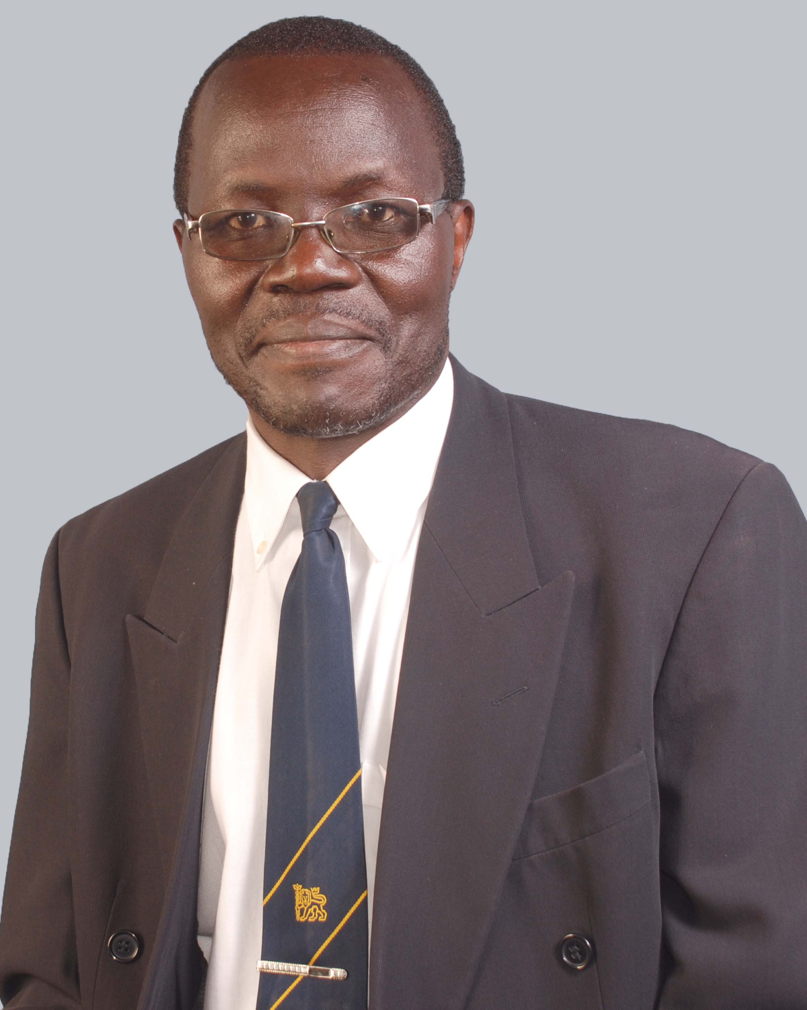

RESUME:
Contact Details:
Name: Chesoli Davis.
Cellphone: +254711863169; +254706066802;
Email: davis_chesoli@yahoo.com;
Current Position: Managing Director/CEO KGOBISA WACHERO EPC LTD
Previous Position: Electro-mechanical Engineer. – ASPAC INTERNATIONAL E.A.LTD (BELGIUM EPC CONTRACTOR)
Professional Summary
I have over 10 years of experience working in manufacturing industry, Hospital, Academia and 1 year in drinking water, wastewater, environment and Energy. Primarily focused on building engineering services and maintenance of HV/LV power distribution network and indoor substation at 11KV/415V and implementation of energy management systems. Presently focusing on planning of drinking water/ wastewater systems; conceptualizing, developing and designing of innovative/ state of the art electrical/electromechanical systems and PV systems.
Professional competence and Skills.
- Honest and open minded; Time management
- Goal oriented and self-driven; Good problem analysis and solving skills.
- Strong interpersonal skills and teamwork,
- Technical and managerial problem solver.
- Self-directed and a believer in transparent communication and social trust among other team members.
- Integrity and servant leadership qualities.
- Ability to work under pressure to complete multiple tasks and meet deadlines on day – to-day general management.
- Energy management policy formulation and design of off - grid and grid-tied solar systems.
- Microsoft word and excel, power point presentation and AutoCAD (Electrical)
Work related Capability:
- Creative and innovative
- Project planning and management
- A key eye for details and critical mind
- Work effectively to support various levels of management
- A high level of self-motivation, commitment and dedication.
- Engineering projects economic appraisals and evaluation, and Estimation and costing.

Professional Experience
2nd Oct, 2017 to Oct, 2018 Electro - Mechanical Engineer.
ASPAC INTERNATIONAL E.A.LTD
Duties and Responsibilities
Technical works:
- Overall planning of drinking water/ wastewater systems; conceptualize, develop and design innovative/ state of the art electrical/electromechanical systems and PV systems.
- Present the systems and arrive at an agreement with the clients; Manage, coach and lead projects Electro-Mechanical engineers.
- Check, propose correction if needed and approve electrical/ electromechanical systems and PV systems.
- Identify and select suppliers, partners, subcontractors, and evaluate, and adapt their offers.
- Calculate costs and determine prices; Plan in details the execution of the installation/ construction works;
- Organize, coordinate and lead teams of engineers/ technicians to install /construct the systems.
- Verify and approve orders; Inspect worksites and provide appropriate guidance to improve the works where and when needed.
- Design creative/ innovative solutions to assist solve/ trouble shoot problems.
- Prepare and attend projects review meetings with clients and /or their representatives.
- Manage suppliers/subcontractors contract, Verify, correct if need be, and approve invoices from suppliers/subcontractors.
Management Responsibilities:
- Development of electro-mechanical business unit within the ASPAC Companies/ offices; Manage the development and the execution of projects.
- Propose and justify measures to always and cost-effectively improve and strengthen the company and its efficiency.
- Recruitment of talents and presentation of result-oriented projects reports

Jan, 2010 – March 2017:
Head of Electrical Engineering Section - Kenyatta National Hospital - Kenya
Achievements:
- Trained and managed 35 technical staff, ensuring adherence to safety procedures and maintenance of high quality service standards expected by management
- Implementation of statutory services and repair of lifts and dumbwaiters through government registered lifts/ dumbwaiters inspectors and contractors.
- Carried out utilities consumption trend analysis annually and developed energy management policy and implementation strategies.
- Prepared and implemented annual program based budgets for all Electrical sectional activities for plant and machinery, and Estate Street lighting.
- Ensured efficient and effective utilization of allocated resources.
- Developed and implemented standard Operating Procedures, and annual operating plans in line with Divisional operating plans.
- Spearheaded culture change to improve the image of the Department, Division and Hospital at large.
- Ensured professional standards, practices and guidelines are applied to all works, installations, facilities and equipment in the Hospital.
- Advised regularly on technical aspects in electrical activities and services and Ensured planned preventive maintenance (PPM) for all hospital power distribution network and elevators
- Carried out quarterly, annual expenditure and power consumption trend analysis for the general management decision- making.
- Monitored and supervised works in progress on site ensuring engineering specifications and standards are maintained.
- Initiated designs for new electrical installations , renovation and updates, development and production of tender working drawings and bills of quantities for tender or direct works in liaison with building and mechanical engineering services officers in accordance with Government building organization manuals, IEE and other Engineering regulations in force.
- Implemented skills development training program of Electrical technicians, artisans and mates, and electrical energy conservation and saving measures staff.

MARCH 2007 UPTO JUNE 2010
Member of the Hospital’s Procurement Committee in pursuance of the Public Procurement and disposal regulations 2006.
Achievements
- Successful deliberations and award of various quotations within the legal threshold, and approval of submissions by the supplies and procurement Department.
- Enhance service delivery due to fast approvals of submissions from supplies and procurement department of the Hospital. Allow justifiably resubmission of any rejected submissions from procurement Department.
1990- 1999 Lecturer – Mombasa Polytechnic,(Presently, Technical University of Mombasa)
Departments of Electrical & Electronics Engineering and Medical Engineering
Achievements
- A senior Examiner with the Kenya National Examination Council at both Diploma and Higher National Diploma level in Medical, electrical and electronics engineering for over 15 years.
- A Co-founder and member of the Current Association of Medical Engineers of Kenya and Supervision of over 100 Diploma and Higher Diploma Final year Examinations projects. Engineering.
- Curriculum developer for Diploma and Higher Diploma Courses in Medical and control engineering at the Kenya Institute of Education for 9 years.
- Development of a fully-fledged Medical Engineering Department at the then Mombasa Polytechnic in transiting to a Public University which now offer Bachelors Degrees in Medical Engineering under its own charter.
- Initiation of several income generating courses to improve facilities and motivate lecturers among others support staff in the Department.
Present consolidated salary: US $3700
Benefits (ASPAC INTL): Medical cover (dental and optical, general health for self and family), Cellphone and airtime allowance, Self-Driven Double Cabin Vehicle
Expected annual consolidated Salary: US $80,000 annually + plus other benefits (gratuity or pension whichever is applicable) and other allowances; and tax exemption if relocated to a different Country).This expected salary is negotiable depending on the country or station of engagement.

Educational and Professional Qualifications:
Holds a Bachelor of Science Degree in Electrical and Electronics Engineering, Postgraduate Diploma in Electrical and electronics engineering, senior management certificate in public sector management, Diploma and Higher Diploma, Diploma in Education, specialized solar design training certificate etc. I have experience of over 10 years in a Hospital, manufacturing industry and in the academia as a lecturer. Previously an associate member of institution of Electrical &Electronics Engineering (UK), South African Federation of Hospital Engineering (Reg. No .N0276) and a member of the Association of Medical Engineers of Kenya, and A registered graduate Engineer with Engineers Registration Board of Kenya (Reg.NO.11859). An alumni of Cardiff University (United Kingdom) and Jomo Kenyatta University of Agriculture Technology (Kenya).
Table 1.0
EDUCATION AND TRAINING
INSTITUTION | YEAR | GRADE/AWARD | AREA OF SPECIALIZATION
Jomo Kenyatta University of Agriculture | 2016 | Bachelor of Science Degree – Electrical & Electronics Engineering | Electrical and Electronics Engineering(Heavy Current option)
University Of Wales  Cardiff- United Kingdom. | 1996 | Postgraduate  Diploma | Electrical & Electronic  Engineering( Control Engineering  Minor)
Mombasa Polytechnic(presently  Technical University of Mombasa) | 1987 | Higher  Diploma | Electrical Engineering  (machines, utilization&  Power supply Technology)
Mombasa Polytechnic(Presently  Technical University of Mombasa) | 1992 | Diploma in Education  (pedagogy) | Teacher Training Education
Kenya Polytechnic(Presently Technical University of Kenya)-Nairobi | 1981 | Diploma | Electrical & Electronics  Engineering
Kenya school of Government (K.I.A)-Nairobi | 2013 | Senior Management course NO.SMC/2264 | Public Service Management

Table 2.0
PROFESSIONAL BODY REGISTRATION AND NATIONAL COMMITTEE REPRESENTATION.
Professional Body | Membership status/class
Engineers Board of Kenya (EBK) | Graduate Engineer - Reg.No .B11859,  Licensed for year 2017 ; 2018 & 2019
Institution of Electrical and Electronics Engineers (IEE) - United Kingdom | Member .Reg.no. 31577865
South African Federation of Hospital Engineering (SAFHE) | Member. Reg. No N0276
Association of Medical engineering of Kenya(AMEK) | Member.Reg.no.MO575
IEEE PES(Power & Energy society) – ISO 50001 | Lead Energy Auditor
Kenya National and events Committees Representation | Previous member
Electrical Engineers world group | Member
African standardization Energy commission(AFSEC) | Previous member AFSEC TC 13. Electrical energy management& load control
IEEE Dielectric &Electrical insulation group | member

ENGINEERING CONSULTANCY
AREA OF CONSULTANCY | INSTITUTION/SPONSOR | LOCATION | RESULTS/ACHIEVEMENTS
Energy Management Survey | Dutch Mission sponsored Hospitals ( Hospital Engineering Projects on Utilities) | Tabora / Singida  Tanzania | Report on Viable Energy usage Options submitted to the Hospital Projects Management Team for sourcing Funds from Denmark

PROFESSIONAL DEVELOPMENT COURSES/WORKSHOPS

PERIOD | COURSE | AREAS COVERED | RESULTS/ACHIEVEMENTS
1999 | Energy and Power Plant systems management | Management of Energy & Power Plant systems | A certificate in Energy and Power Plant systems management.
2008 | PPOA/ARD Training  In Public Procurement | Act and Regulations; Roles of committees; Procurement Planning; Choice of Procedure; Requirements; Receipts of bids and tender evaluation. | A certificate of Participation
2008 | Facilities Management Principles and Practice Foundation Course | Facilities management Discipline; competencies;  Organization; Function and Risk, Financial and value; quality and performance; Information and Maintenance management; workplace planning; Support service. | A certificate in facilities Management
2014 | AutoCAD Electrical | Electrical systems design and simulations | Self-trained
2014 | Energy management Lead Auditors | Energy management –Lead Auditors Training | Energy Audit
Feb,2018 | Specialized solar Design Training | Certificate in Specialized solar Training-Schneider Electric Academy. | Specialized solar Training(solar power design)

