
ashishbatu@gmail.com +971-588935132/+91-9665024021

Aashish Arun Bandekar

PROCESS ENIGINEER

Expertise in working on multiple projects with hands-on experience in different projects in Petrochemicals, Chemical and Oil & Gas Industries

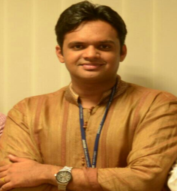

Profile Summary
Total 6.5 years of experience which includes assignments in different projects in Oil &Gas / Petrochemicals process units. Involved in Detailed Engineering as well as FEED projects in Chemical, petrochemical, Fertilizers, Pharma, Water etc. Expertise in work share jobs with Leiden & Houston office. Expertise in working on Detail Engineering jobs of EO/EG Technology for Reliance &MEGlobal, General process engineering activities carried out include preparation and updation of Process Flow Diagrams (PFD’s), Piping and Instrumentation Diagrams (P&ID’s), preparation of data sheets for equipment like Pumps, Vessels, Safety Valve sizing calculations, Line sizing calculations, preparation of data sheets for instruments, Line list, Utility summary, Hazardous area classification summary and Review of Vendor documents.
A result-oriented individual having strong analytical, communication, interpersonal and organizational skills.
Education
- Pursuing PGDM (Operations Management) from Welingkar Institute of Management, Mumbai
- B.Tech. (Specialization) from Dr. Babasaheb Ambedkar Technological University, Lonere in 2011 with 6.56 CGPA
- 12th from S.S.V.P.S College, Dhule in 2007 with 74.17%
- 10th from Jai Hind High School, Dhule in 2005 with 83%
Other Course
Core Competencies
Design Engineering
Technical Support
Vendor Management
Operations
Reporting & Documentation
Project Execution
Team Building & Leadership

- Piping Engineering from Maharashtra Institute of Technology, in 2012 with 66%
Trainings Attended
- PIPENET Software
- HTRI
- PIPESIM
- PDM (Plant Design Manager)
- Hysys
- Bluebeam
Soft Skills

Team Player Analytical
Collaborator Communicator Planner

Timeline
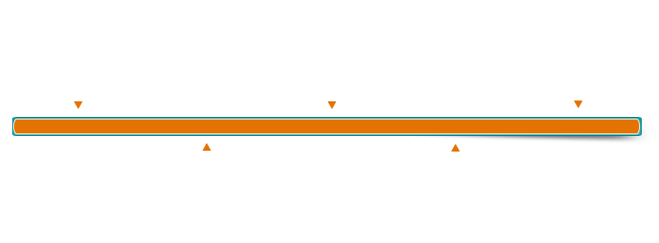
2012 – 2017
2012
2011
2007
2005
Jacob Engineering India Pvt. Ltd. Navi Mumbai as Process Engineer

PGD in Piping Engineering, MIT Pune with 66%
12th from SSVPS College, Dhule
with 74.2%
B.Tech in Petrochemical,
Dr. Babasaheb Ambedkar
Technological University,
Lonere with 6.56 CGPA
10th from Jai Hind High School, Dhule with 83%
Work Experience
Jacobs Engineering Group Inc.,
Navi Mumbai, India
September 2012 – September 2017
DuFlon Industries Pvt. Ltd.,
Mumbai, India
September 2017 – March 2018

Dodsal Engineering and Construction Pte Ltd
Dubai, UAE
May 2018 – Present

Key Result Areas:
- Development of Process Flow Diagrams (PFD’s), Utility Flow Diagrams (UFD’s)
- Integration Study of Pipeline Network in PIPESIM
- Preparation and modifications of P&IDs
- Separator sizing
- Line sizing (Single phase & Multi phase)
- Hydraulic calculations for Pumps
- Control valve calculation
- Chemical consumption calculation
- PSV Sizing
- Inbreathing & Outbreathing Calcutation for Atmospheric Storage Tanks
- Preparation of Utility summary and Battery Limit Schedule
- Preparation of Instrument process datasheets (IPDS)
- Preparation of DPDT Diagram
- Preparation of Line List
- Preparation of SM List
- Equipment Datasheet
- Datasheet of Strainers, Filters, Silencers etc
- Preparation of Analyzer Datasheet
- Preparation of Hold List
- Model Review
- Updating of Interlock Description and Cause & Effect Diagram
- Preparation of Pressure Profile Diagram & Safeguarding Diagram
- Acoustic Induced Vibration (AIV) and Flow Induced Vibration (FIV) Analysis
- Calculation of Cooling Tower
- Vendor document Review of Pumps, Vessels, Raw water treatment package, Air compressor, Cooling Tower, Boiler package etc.
- P&ID Markups & P&ID change note (PCN)
- Isometric Squad checking activities to minimize the P&ID and isometrics mismatches on site
- Preparation of IBR flow diagrams and Line list in RIL MEG project
- Prepared Electric tracing line list and coordinated with Electrical department in RIL MEG project
- Helped to prepare HAZID CAR Closure Report & LOPA CAR Closure Report in RIL MEG project
- Closure of HAZOP points in RIL MEG & SONATRACH South HGA project
- Other Activities:
Input to Electrical Department for Electric Tracing
Input to Instrumentation department ex. Stream velocity for Analyzer probe
Input to Stress department ex. Identified probabilities of generating Slug flow in two phase line
Significant Accomplishments:
- Appreciation for value addition work in SONATRACH project.
- Acted as an independent lead of Offsite area which includes 130 P&IDs. Also developed Flowline, Manifold and Trunkline network for 49 wells by using PIPESIM
- Received Appreciation Certifications from clients for working within the team in 2013 & 2015 respectively
- Second rank in PGD Piping design Engineering, MIT Pune
- Detail Engineering for J3-MEG, Reliance, Jamnagar
- In 2017, passed paper of “Energy Efficiency in Electrical Utility” and “Thermal Engineering” of BEE Energy Auditors Exam

Major Projects:
- SONATRACH (Algeria):
EPC Oil & Gas (Onshore) project (Greenfield / Brownfiled) for the separation and compression centre, part of US $1.1 billion plant near South HGA-HassiMessaoud, Algeria.
- Reliance Industries:
FEED & Detail Engineering for 550 KTA EO/EG Plant (MEG Plant) in Jamnagar, India. The project based on DOW chemical EO/EG technology.
- MEGLOBAL:
FEED and Detail Engineering for 750 KTA EO/EG Plant (MEG Plant) in Texas (Work share with Houston office)
- Group OCP:
Detail Engineering (Phosphate Plant), Morocco
- VCM:
PDP preparation for YMHT, China & OXY5, Korea with Oxyvinyls as Licensor
- Rohit Surfactants PVT LTD:
Detail Engineering (Soda Ash Plant)
- GLT-NAM:
As built P&IDs’ of Norg GLT PLUS projects Netherlands

Personal Details
- Nationality: Indian
- Sex: Male
- Marital Status: Married
- Date of Birth: 22 July, 1990
- Passport No: L2458388
- Visa / Status: UAE / Active
- Current Address: 142, Sahara Building, Al Qusais, Dubai, UAE
- Permanent Address: 403, 1-A, Radhey Heritage, Panvel, Navi Mumbai, Maharashtra, India

