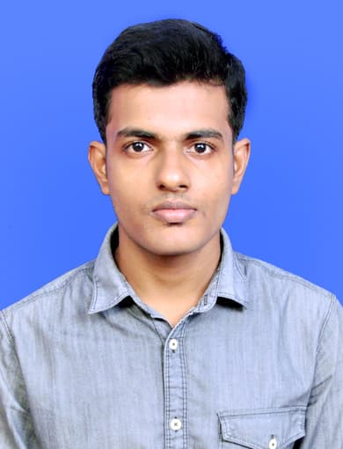
SHREE KUMAR MISHRA
Phone: +91-9124732131 | Email: shreekumishra@gmail.com
Date of Birth: 2nd March 1995 | Marital Status: Unmarried
Languages Known: Odia, Hindi, English | Nationality: Indian
Address: At-Balabhadrapur Sasan,Keseria,Po-Korian,Dhenkanal
State-Odisha,Country-India (759013)

Career Objective
To work in a challenging environment demanding all my skills and efforts to explore and adapt myself in different fields and realize my potential where I get the opportunity for continuous learning.
Educational Background
- Course: Bachelor of Technology in Applied Electronics & Instrumentation Engineering
College: C.V. Raman College of Engineering,Bhubaneswar (2012-2016)
University: Biju Patnaik University of Technology,Odisha
Performance: CGPA-7.32/10
- Course: Intermediate
College: SCS Junior College,Puri (2010-2012)
- Course: Standard 10th
School: Jawahar Navodaya Vidyalaya,Sarang (2010)
Vocational Training
- Summer Internship At National Thermal Power Corporation Limited,Kaniha
- Project Report- Synopsis of Thermal Power Plant.
- The above project is a complete survey report of all the departments at National Thermal Power Corporation Limited,Kaniha. The purpose of this survey report was to get the technical view of a thermal power plant.
Professional Coursework
- PLC (Programmable Logic Controller)
- NI LabVIEW (Laboratory Virtual Instrument Engineering Workbench)
- VLSI Design (Analog and Digital)
- DCA (Diploma in Computer Application)
Journal Publication
- “Design of Different Control Strategies for a Boiler Drum System using LabVIEW”. Journal of Control System and Control Instrumentation. [Volume 2 Issue 1, 2016]
Overview: This paper provides the comparative performance analysis of different control strategies such as feedback, feed forward, feedback-feed forward, cascade and Internal Model Control (IMC). The designed model of boiler drum level controller was simulated using LabVIEW software.

Technical Knowledge
- Operating Systems Windows – 10, 8, 7, XP
- Simulation Softwares
Xilinx ISE | Pyxis Schematic | NI LabVIEW | IndraLogic | Matlab | Multisim
- Tools
Final Control Elements | Transducers/Sensors | Electronics Equipments
- Software/Applications
MS Word | MS Power Point
Professional Strengths

• Possess a wide knowledge of schematic diagrams and wiring diagrams.
• Ability to read and understand technical drawings/figures.
• Ability to identify, replace and explain the proper use of equipments/sensors.
• Ability to quickly understand new systems and their requirements.
• Possess excellent verbal and written communication skills.

Intra-College Activities
- Certificate from Texas Instruments Analog Design Contest 2015
- Certificate from Cambridge ESOL Examinations 2013
- Certificate from National Service Scheme (Ministry Of Youth Affairs & Sports) 2011
Interpersonal Skills
Quick Learner | Initiative | Flexible | Motivator
Hobbies/Interests
Painting | Watching News | Playing Chess | Travelling

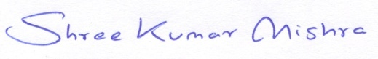
Date: 30|01|2018 Signature
Place: Dhenkanal (Shree Kumar Mishra)

